2020-2023

COMMUNITY HEALTH IMPROVEMENT PLAN

for north central Iowa
July 6

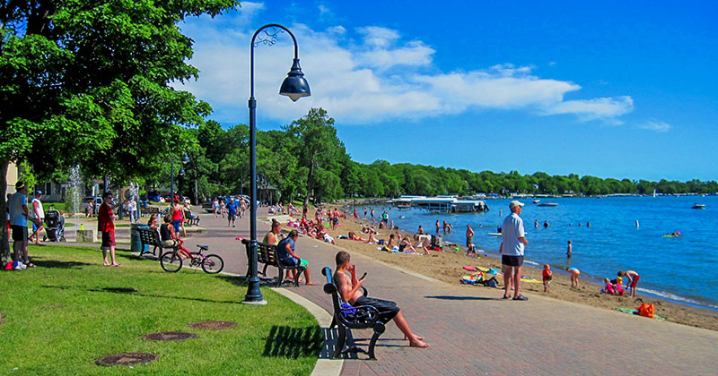
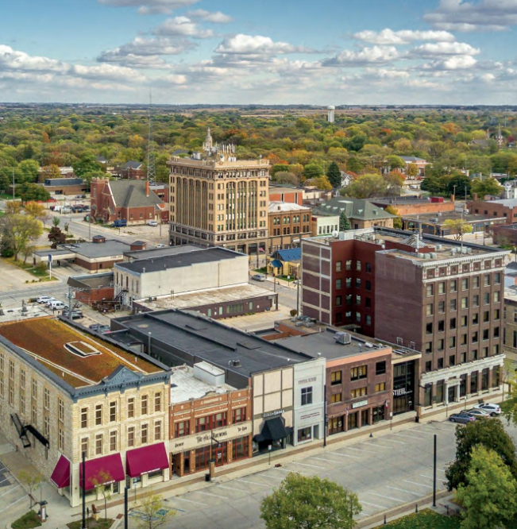
Date Adopted: MM / DD / YYYY

Palo Alto County, Iowa 3201 1st Street Phone: (641) 421-9300
Palo Alto County Public Health Emmetsburg, IA 50536 www.pachs.com

2020- 2023 Community Health Improvement Plan
Table of Contents
2020- 2023 Community Health Improvement Plan 2
Letter to the Community 2
Executive Summary 3
MAPP Framework 4
2020-2023 Palo Alto County Health Improvement Plan 8
Health Priorities 8
Priority 8
Areas to Address Under Priority 8
Access to Care 8
Stigma, Service Delivery, Aging, Advocacy 8
Early Childhood Issues 8
Poverty, Housing, Childcare, Education, Literacy Skills 8
Housing 8
Maintenance of Existing Housing, Contractor Capacity, Housing Development, Rental housing 8
Priority 1: Access to Care 9
Priority 2: Early Childhood Issues 11
Priority 3: Housing 15
Acknowledgements 18
Appendix 18

Letter to the Community

Dear Palo Alto County Residents,

We are pleased to present the 2020-2023 Palo Alto County Community Health Improvement Plan, produced by Palo Alto County Public Health in conjunction with CG Public Health. The Community Health Improvement Plan (CHIP) is a county-wide effort to address the concerns stated in the Community Health Assessment (CHA). This plan is developed through listening to the community members and looking for patterns that contribute to health issues.

Many agency representatives and community members created action plans for community-selected top priority areas. We want to thank the many individuals, agencies, and organizations for their dedication to improving the health of northern Iowans through attending meetings, participating in activities, and developing policies. These individuals and agencies have helped and will help ensure the success of the CHA-CHIP.

A community must provide input on how to improve the health and wellbeing of their communities. Just like a person makes decisions that affect their health, our communities can do the same thing. We invite everyone throughout the County to participate in tackling health priority areas discussed in this plan. The CHIP is a roadmap of change that lays out how to address complex health issues like stigma and poverty, but such change does not happen overnight. Together, over time, we can make progress to promote and protect the health of all individuals, families, and communities who live, learn, work, pray and play in north Iowa.

Be a part of the solution by educating your family, neighbors, friends, and colleagues. Want to get involved? Contact PA Public Health at 712-852-5419 to learn more about health improvement. At a minimum, share the information in this document that you found surprising or most eye-opening on social media, or at your next dinner party. Every north Iowan has a role to play.

Sincerely,

The Health Improvement Collaborative

Executive Summary
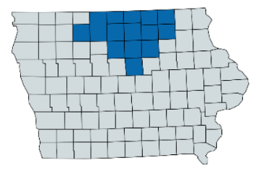
In early 2019, the process of conducting the first iteration of a regional north-central Iowa Community Health Assessment (CHA) and Community Health Improvement Plan (CHIP) began. For the first time, the CHA-CHIP process worked together as a 14-county region. Health problems and priorities do not vary widely from county to county, therefore working together will strengthen partnerships, maximize resources and impact for north Iowa. Participants considered social determinants of health, causes of higher health risks for specific populations and health inequity. Throughout this process, the community vision and values guided discussion and direction. Fifteen organizations joined together using the Mobilizing for Action through Planning and Partnerships (MAPP) model, a community-based model that necessitates community engagement at all levels to conduct the CHA-CHIP. We assessed the current health status of communities across 14 counties, identified needs, and created a comprehensive plan by eliciting input from residents, community organizations, and other stakeholders to methodically improve the community’s health. For more information on the assessment of health issues, read the Community Health Assessment Report 2020.
Through this assessment and planning process, various issues were identified, and three health priorities were voted upon to be addressed during the next 3-year implementation period. Those priorities are:
- Access to Care
- Early Childhood Issues
- Housing
Figure 1: North Iowa Region
These priorities served as starting points in the development of the CHIP. The purpose of the Community Health Improvement Plan (CHIP) is to identify how to strategically and collaboratively address health priority areas established to improve the health and well-being of our community. This document outlines the process for how the community prioritized strategic issues and formed goals and strategies to guide the community through the development and implementation of action plans for each health priority in the 2020-2023 CHIP. There is an emphasis on addressing root causes, using evidence-based approaches with health equity at the center of all activities to ensure everyone has a fair and just opportunity to achieve optimal health and well-being.

MAPP Framework
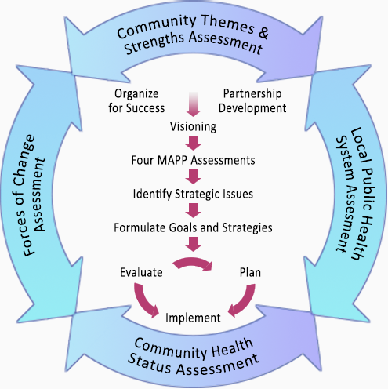
MAPP is a community-wide strategic planning tool aiming to improve community health. The framework was formed by the National Association of County and City Health Officials (NACCHO) and the Centers for Disease Control and Prevention (CDC). The MAPP framework was selected because it emphasizes engaging local public health system partners and community members in a collaborative assessment and planning process. Furthermore, this is the second iteration that Cerro Gordo County has used the MAPP framework to inform the CHA-CHIP.
The six phases of the MAPP framework include:
- Organizing for Success and Partnership Development
- Visioning
- The Four Assessments
Figure 2: MAPP Model

- Identify Strategic Issues
- Formulate Goals & Strategies
- Action Cycle

Organizing for Success and Partnership Development
In early March of 2019, the current CHA Steering Team decided to complete this iteration of the CHA-CHIP as a region for the first time. The CHA Steering Team began recruiting other organizations that were not currently members of the Health Improvement Collaborative. Before the official kick off meeting, 15 organizations joined together to begin planning the CHA. The initial meeting of all interested participants took place on March 25th, 2019. For the CHIP, partners were less engaged. Most of the planning was completed by the core team and some of the partners like Prairie Ridge Integrated Behavioral Healthcare, North Iowa Children’s Alliance, North Iowa Area Council of Governments, Hancock County Public Health, Youth Task Force, and North Iowa Community Action Organization employees. See the Acknowledgements section starting on page 18 for a membership list of those involved.
Visioning
In June 2019, the CHA Steering Team met at Turning Leaf Counseling to brainstorm the vision and values that would serve as their roadmap for the next few months. The ST reviewed the 2015-2019 values and compared various options such as a short, simple version to a more wordy, complex option. The team agreed upon a short, to-the-point vision and values to guide them.

Community Health Assessments
There are four assessments used in the MAPP framework. These assessments occurred between March 2019 through December 2019.
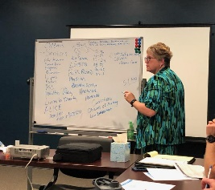
- Community Themes and Strengths Assessment
  - To get a deeper understanding of the issues that residents feel are important, the team conducted focus groups, key informant interviews, and a survey that was distributed throughout the 14-county region. There were over 750 responses to the survey. This assessment also helped the planning team understand assets and resource our region has available to improve population health.
- Local Public Health System Assessment
  - Due to the COVID-19 response, this assessment within this MAPP step was not completed. Unfortunately, the timing of this assessment fell around the height of the COVID-19 response, and the local public health system did not have the capacity to complete this.
- Community Health Status Assessment
  - Health Department staff partnered with Iowa State University students who compiled various data sources to provide important statistics for the Community Health Assessment. The students gathered data for Cerro Gordo County and Health Department staff collected data for the rest of the region.
- Forces of Change Assessment
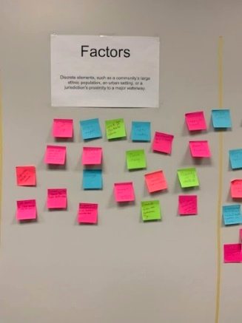
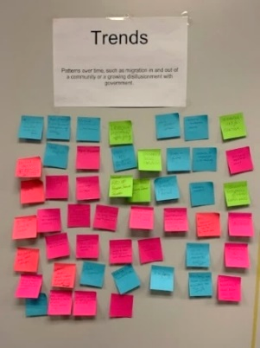
  - The Steering Team met at CG Public Health to participate in this assessment. The group used sticky notes to identify events, trends or factors that have or might affect the health of the community or the local public health system.
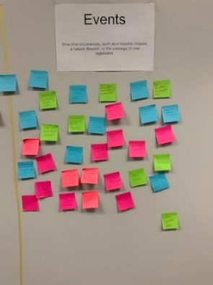

Strategic Issue Identification
Strategic issues are defined as issues that must be addressed for the Health Improvement Collaborative to achieve its vision. The MAPP Core team created the following categories based on the data, themes, and findings from the community health assessments. The list of issues was provided to the facilitator prior to the strategic issue prioritization meeting (Community Health Forum). See the table below.

- Cancer | - Dental Access
- Diabetes | - Mental Healthcare Access
- Heart Disease/Stroke | - Obesity/Healthy Food
- Aging | - Sexual Health
- Infectious Disease | - Suicide
- Injury | - Alcohol Abuse
- Healthcare Access | - Driving Under the Influence
- Water Quality | - Substance Use including Nicotine

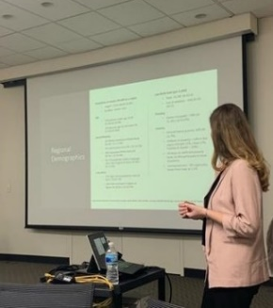
In January of 2020, a Community Health Forum was held to present the Community Health Status Assessment summary to residents and various organizations. Before the forum, there was a major marketing push to spread the word to try and encourage residents to attend. To engage the community, CG Public Health and many partners posted about this event on their social media platforms, and even went on a local radio station to educate local listeners on what a CHA-CHIP is, the importance of community input, and how they can get involved. The presentation covered a little background about who was involved in this process, the vision and values, quantitative and qualitative data, and local health influences.
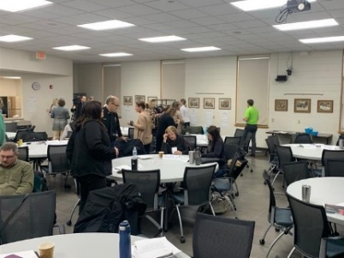
After the presentation, a professional facilitator led an in-depth discussion to help the group identify and prioritize strategic issues. Each health issue was on a piece of paper hung on the walls within the meeting room. Each participant used three-star stickers to vote on their top three health issues for each of the criteria. For example, they may have voted for three issues that have a significant impact. The facilitator listed six criteria for prioritization. The questions the facilitator asked regarding the criteria for prioritization were:
- “What health issue affects the most people within the population and has serious consequences for those affected?”
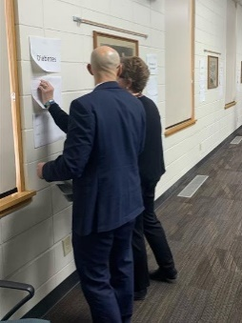
- “What health issue does north Iowa lag behind on and/or is not on track to achieve Health People 2020 goal?”
- “What health issue disproportionately impacts the health status of one or more subpopulations?”
- “What health issue is the primary link to chronic disease and related health outcomes and does this issue have serious health consequences?”
- “Local efforts are likely to result in meaningful improvement in the scope and/or severity of this health issue.”
- “What indicator represents a significant opportunity to improve health outcomes using prevention-focused approaches?”
In the end, the stars were added on each health issue sheet to see what the top health issues were based upon the exercise. Participants chose Access to Care, Early Childhood Issues and Housing as their three top health priorities after in-depth discussions. These health priorities were used as a starting point in the development of the Community Health Improvement Plan.
Developing Goals and Strategies
To achieve our vision, the CHIP must address social determinants of health and place health equity at the center of each strategy written within the plan. Before each brainstorming session in this step, the facilitator read the definition of health equity and showed a visual depicting the importance of helping every person attain their full health potential.
Due to COVID-19, this step in the MAPP process occurred virtually via Microsoft Teams. The Steering Team was invited to participate in health improvement plan meetings to begin planning for the CHIP. The purpose was to develop the goal and strategies for the three top health priorities established in the previous MAPP step. Prior to the first meeting, the ST members were emailed a copy of the Community Health Assessment report to review.
As the ST began to brainstorm strategies, they were encouraged to intentionally think about strategies at the public policy, community, and organizational levels to ensure systems change. Strategies must occur at various levels of the socio-ecological model to sustain implemented prevention efforts over time and achieve population-level impact. To achieve health change successfully, organizations should and will work together to shift populations to better health outcomes with consideration of the Model. Throughout the following strategies, you will note interventions built on all these levels to recognize different factors that affect health and the change needed.
Figure 3: Socio-Ecological Model

The meetings included a goal-setting exercise, which asked the participants three questions about the health priority issue of focus, (e.g., Access to Care). The questions were:
- “What needs to happen to ensure Access to Care is available and achieved in our community?”
- “Why do you think Access to Care is lacking in our counties?”
- “How would you know there is Access to Care?”
Participants were given roughly a minute to brainstorm and record their responses. Once all questions had been presented, a virtual sticky note session began using Padlet, a collaborative web-based platform in which users can upload, organize, and share content via virtual bulletin boards. The questions were asked again, this time asking for participants to share their responses. After this step, the group was asked to identify categories for Access to Care. This was done by seeing what responses were repeated multiple times or were similar. Headings were created and the group decided upon four main categories for access to care: stigma, service delivery/care coordination, aging, and advocacy. Finally, the group developed goal statements for each category.
Lastly, the group was assigned homework at the end of the session: to develop strategies for each identified category. Participants were instructed to insert their strategies directly into Padlet using the provided link or record them on an Excel sheet and send to the facilitator before the next meeting date. This same process was repeated for the other two healthy priorities. The strategies listed in Padlet and sent via e-mail provided a strong start to the CHIP.
After the three health improvement plan meetings were held, the group took a five-month break to lead in the distribution and administration of COVID-19 vaccines throughout their communities. In June, the demand for vaccine had decreased drastically; therefore, CHIP planning could resume. The facilitator reviewed the strategies the group listed and drafted the CHIP. This draft of the CHIP was sent to the Health Improvement Collaborative, various community organizations and community members who work in housing, healthcare, or early childhood services throughout the 14-county region. Those providing input were asked to reference the socio-ecological model (see Figure 3) when forming the action plan and consider using evidence-based programs to address issues. Together, action plans for each strategic issue complete the CHIP. Activities for each strategic issue are planned through 2023.
Once strategies were chosen, one of the core team members completed a Health Equity Impact Assessment (HEIA), which is tool to be used to identify and address potential unintended health impacts (positive or negative) of a policy, program, activity, etc. Step one is to identify specific populations that may experience significant unintended health impacts. The populations assessed included age-related groups, disability, ethno-racial communities, homeless, linguistic communities, low income, religious/faith communities, rural/remote communities, sex/gender, and sexual orientation. Next you consider the population’s determinants of health. Thirdly, you list the unintended positive and negative impacts. For example, if one of the activities is to encourage the use of an online resource directory, not all people have access to the internet, or can afford it (negative impact). Next step is to identify ways to reduce negative impacts and maximize the positive impacts. To ensure success is measured, each strategy/activity is assigned a performance measure. Lastly, confirm how the results will be shared with the appropriate stakeholders. See the Appendix section for a copy of this HEIA tool starting on page 20.
Action Cycle
The action cycle links the planning, implementation, and evaluation of the CHIP. To ensure the efforts of previous phases produce results, implementation teams (committees) will be formed for each priority. The teams will oversee the specific strategies listed in the action plan and be responsible for monitoring and updating their goals.

2020-2023 Cerro Gordo County Health Improvement Plan

Health Priorities
Below is a description of each priority area, risk factors, and indirect and direct contributing factors selected for each of the health priority areas. These health plans were developed in partnership with community leaders representing multiple agencies and organizations.
Priority | Areas to Address Under Priority
Access to Care | Stigma, Service Delivery, Aging, Advocacy
Early Childhood Issues | Poverty, Housing, Childcare, Education, Literacy Skills
Housing | Maintenance of Existing Housing, Contractor Capacity, Housing Development, Rental housing

Priority 1: Access to Care
Access to affordable, accessible, quality health care is vital to physical, social, and mental health. The timely use of personal health services can help ensure everyone has the opportunity to achieve the best health outcomes for themselves.
Access to care was a reoccurring theme throughout the entire Community Health Forum. In the region, we have our own set of issues regarding access to care. To reach our goal, our group plans to create systems change by hitting the policy, organizational and intrapersonal levels within the socio-ecological model. The action plan will tackle key contributors to the access to care issues by addressing the stigma embedded into our current healthcare system by offering trainings to those working healthcare for stigma and cultural competence, engaging non-traditional partners to ensure community health services are available, revitalizing the Community Care Coordination (CCC) model, and recruiting and retaining providers to improve the provider to patient ratio.
GOAL # 1: Increase opportunities for all people so they, regardless of insurability, will have access to timely, culturally competent, high-quality care and community services.
OBJECTIVE #1: By 2023, decrease the number of Level 4 and 5 Emergency Department visits by 10% by connecting patients with a medical home/provider in the clinic setting.
BACKGROUND ON STRATEGY
Source: MercyOne
Evidence Base: https://bmcmedicine.biomedcentral.com/articles/10.1186/s12916-019-1256-2
https://www.ncbi.nlm.nih.gov/pmc/articles/PMC4106584/
Policy Change (Y/N): Y
ACTION PLAN
Activity | Target Date | Resources Required | Lead Person/ Organization | Anticipated Product or Result
Complete a policy assessment on current policies in place (e.g. – no show policy) that address stigma. Determine if further action is necessary to improve the system in place to prevent stigma within the healthcare settings/other organizations. Use the HEIA on the policy implemented. Consider implementing an anti-stigma policy if one is not yet adopted. | 09/01/2022 | -Staff time | Access to Care Committee, All | -Policy change/updates
Schedule an annual training for medical providers about cultural competence, health equity, social determinants of health and cultural humility to combat external stigmatization | 09/01/2022 | -Meeting room  -Technology  -Health Stream Access | MMC-NI | -Increased knowledge  -Written resources
Offer a workshop/speaker event hosted for the community specifically for those who are experiencing stigma – teach them coping mechanisms/ | 06/31/2023 | -Meeting room | Access to Care | -One workshop hosted
Schedule a bi-annual training/workshop for stigma for providers/healthcare workers. (e.g. – Understanding Stigma or Combating Stigma) | 09/01/2023 | -Meeting room  -Technology  -Health Stream Access | MercyOne North Iowa | -Increased knowledge  -Written resources
Advocate for improved reimbursement rates from Medicaid, decreased costs, and more streamlined process of setting of claims. | 12/31/2023 | -Staff time | All, Access to Care Committee | -Medicaid reform
Establish/revise a process to connect patients entering the ED (Level 4 and 5) to be connected to a medical home | 12/31/2023 | -Staff time | Access to Care Committee | -Increased medical homes for patients
OBJECTIVE #2: By 2023, decrease the percentage of adults reporting fair or poor health to 12% in Cerro Gordo County by expanding the organizations actively engaged in the Cerro Gordo County community care coordination (CCC) model to impact better health outcomes.
BACKGROUND ON STRATEGY
Source:
Evidence Base: https://www.ncbi.nlm.nih.gov/pmc/articles/PMC6359857/
Policy Change (Y/N): N
ACTION PLAN
Activity | Target Date | Resources Required | Lead Person/ Organization | Anticipated Product or Result
Seek funding source and/or support self-sufficiency to support the current CCC model for all partners | 12/31/2021 | -Staff time | CG Public Health | -Increased capacity
Add new Steering Team members/stakeholders and convene at least quarterly | 12/31/2021 | -Staff time  -Meeting space  -Technology | CG Public Health | -Increase collaboration and communication  -Less duplication
Commit to community-wide coordination meetings involving "nontraditional" partners as well as process makers (supervisors rather than policy-making directors) of area agencies who provide health care and/or agencies who assist in patients accessing services. Meet twice a year. | 03/31/2022 | -Staff time  -Meeting space  -Technology | CG Public Health | -Increase collaboration and communication  -Less duplication
Work as a team for patient care in community based and clinical settings | 12/31/2023 | -Staff time | All | -Improved patient outcomes
Incorporate a single, agreed-upon referral resource directory to connect clients/patients to resources/services | 06/30/2022 | -Staff time  -Internet | All | -Increased awareness of resources/services
Add community messaging as a standing agenda item at community coordination meetings | 01/01/2022 | -Staff time | CG Public Health | -Unified messaging
Invite elected officials to community coordination meetings to share legislative priorities | 01/01/2022 | -Staff time | CG Public Health | -Increased awareness of health issues/priorities
Partner with local congregations to provide support groups, faith formation education, and youth outreach around public health goals. | 12/31/2023 | -Staff  -Volunteers | CG Public Health | -Increased awareness of services
OBJECTIVE #3: Improve provider retention and recruitment in Cerro Gordo County increasing the number of providers staying in north Iowa post-residency by 10% by 2023.

BACKGROUND ON STRATEGY
Source:
Evidence Base: https://bmchealthservres.biomedcentral.com/articles/10.1186/s12913-016-1370-1
Policy Change (Y/N): N
ACTION PLAN
Activity | Target Date | Resources Required | Lead Person/ Organization | Anticipated Product or Result
Create an annual marketing and recruiting plan targeting high school and NIACC students to practice in north Iowa post-education | 06/30/2022 | -Staff time | MercyOne North Iowa | -1 marketing and recruiting plan
Insert a budget line item for more scholarship funds to support providers to move back to north Iowa | 12/31/2023 | -Staff time  -Money | MercyOne North Iowa | -Increase in new provider recruits
Physician campaign to promote the area (why they love it here, Mercy promotes local high-end real estate available through introduction packet for the region (also promotes school districts, culture, and recreation), incentivize local preservation and restoration of historic homes | 12/31/2022 | -Technology  -Equipment  -Staff time  -Media partners | MercyOne North Iowa | -1 marketing campaign  Increase in providers practicing in north Iowa
Assess financial incentives to ensure salaries are competitive to retain specialist, hire providers | 12/31/2021 | -Staff time | MercyOne North Iowa | -Increased in providers/retention
Survey residents assessing why they have decided to stay, or decided to leave the area | 12/31/2021 | -Staff time | MercyOne North Iowa | -Increased knowledge

PERFORMANCE MEASURES
How We Will Know We Are Making a Difference
Short Term Indicators | Source | Frequency
# of providers participating in trainings | MercyOne-North Iowa | Annual
# of providers accepting Medicaid patients and new patients | DHS / MercyOne North Iowa | Annual
# of residents remaining in north Iowa post-residency | MercyOne-North Iowa | Annual
Long Team Indicators | Source | Frequency
Decrease in chronic disease/improve health outcomes | County Health Rankings | Annual
Improved provider to patient radio | County Health Rankings | Annual
Increase in referrals to other services | Referral tracking (internal) | Annual
Increase in residents having a medical home | Electronic Health Record | Annual

ALIGNMENT WITH NATIONAL PRIORITIES
Obj # | Healthy People 2030 | National Prevention Strategy
1 |  | Reduce barriers to accessing clinical and  community preventive services, especially  among populations at greatest risk.
2 |  | Enhance coordination and integration of clinical, behavioral, and complementary health strategies.
3 | “Increase the proportion of people with a usual primary care provider”
4 |  | Clinical and Community Preventative Services  (4 Support implementation of community-based preventive services and enhance  linkages with clinical care)

DESCRIBE PLANS FOR SUSTAINING ACTION
- Frequent meeting with Access to Care sub-committee
- Apply for funding/grants to support initiatives
- Activate current coalitions- engage members, encourage action, create a sense of community among agencies (increase cross-collaboration), consistently apply for joint grant applications, share staff, share marketing staff; consolidate current coalitions to create a single, strong, and active coalition (reduce meeting burnout).
- Create policies supporting tele-health in our county
- Continue policies for cultural competence training for providers

Priority 2: Early Childhood Issues
Early childhood is a critical time in a child’s life. Brain development is occurring at a rapid pace, which leads to children being highly influenced by their surrounding environments. The group recognized the urgency of addressing the educational and environmental issues at this early age to ensure children’s successful development into productive and healthy adults. Poverty was a health issue that repeatedly came up during the prioritization meeting. Children in poverty range from 12% (Butler) to 18% (Floyd & Wright Counties) and the region averages 14%. Participating in WIC helps kids get a good start in life. Overall, the state averages 26% of kids on WIC; however, children 0-4 receiving WIC ranges from 9.1% (Worth) to 39.5% (Cerro Gordo).
Another issue plaguing children is homelessness. Head Start children who are homeless range from 0% to 17% (Winnebago). Children experiencing homelessness are more likely to suffer from physical, mental, and emotional trauma, low birth weights, and lack of essential immunizations. Children need to have a safe, stable space to play and grow. Another issue is the extremely high cost of childcare in Iowa. It is reported that childcare can consume more than 54% of a single parent’s annual household income for two children. Lastly, according to the Early Childhood Iowa (ECI) Kindergarten Assessment early literacy skills are subpar in northern Iowa. Reading is vital to a child’s social and cognitive development, wellbeing, and mental health. This health priority will focus on the prevention of early childhood issues in hopes of creating more opportunities for all children to have safe, stable, supportive relationships and environments in north Iowa.

GOAL #2: Increase safe, stable, supportive relationships and environments for children.
OBJECTIVE #1: By 2023, reduce the children in poverty rate from 13% to 12%.

BACKGROUND ON STRATEGY
Source: County Health Rankings
Evidence Base: https://www.sciencedirect.com/science/article/pii/B9780128160657000161
Policy Change (Y/N): N
ACTION PLAN
Activity | Target Date | Resources Required | Lead Person/ Organization | Anticipated Product or Result
Promote youth mentorships program volunteer enrollment and recruit mentors who can teach skilled trades at local community college | 12/31/2023 | -Staff Time | Youth Task Force, NIACC | -Decrease in childhood poverty, unemployment
Advocate for expanding SNAP benefits | 12/31/2023 | -Staff Time | All | -Reduce childhood poverty
Educate community leaders and citizens on the poverty data/prevalence | 09/30/2022 | -Staff Time | Early Childhood Issues Committee | -Increased awareness
Implement an annual child fair every quarter to close the gaps that are leading to that high of a percentage. | 12/31/2023 | -Staff Time  -Venue/Rented space  -Partners | Early Childhood Issues Committee | -Increased awareness
Coordinate and promote job fairs in the low-income areas of our communities | 12/31/2023 | -Staff Time  -Venue/Rented space  -Partners | Iowa Workforce, All | -Increase in expanded work support
Promote referrals to programs in place to assist families in getting out of poverty. Specifically, job placement, Iowa State Extension office, vocational rehab. | 12/31/2023 | -Staff Time | All | -Increased awareness
OBJECTIVE #2: Reduce the number of homeless children in north Central Iowa by 10% through offering more affordable and safe housing by December 31, 2023.
BACKGROUND ON STRATEGY
Source: Head Start
Evidence Base: https://www.usich.gov/resources/uploads/asset_library/Housing-Affordability-and-Stablility-Brief.pdf
Policy Change (Y/N): N
ACTION PLAN
Activity | Target Date | Resources Required | Lead Person/ Organization | Anticipated Product or Result
Develop a plan to connect parents to open housing, education on how to sustain and maintain affordable housing, rental assistance programs, and other services to help lift up the family. | 12/31/2022 | -Staff Time | Early Childhood Issues Committee | -Decrease in childhood homelessness
Develop guidance and messaging targeted toward at-risk children, youth, and families. | 12/31/2022 | -Staff Time | Early Childhood Issues Committee | -Strengthened  communities,  -Increased protective  -Reduction the prevalence of youth homelessness
Educate stakeholders on guidance/messaging | 03/31/2023 | -Staff Time  -Partners | Early Childhood Issues Committee | -Increased awareness and knowledge
Develop coordinated entry systems to identify youth for appropriate types of assistance and to prioritize resources for the most vulnerable youth. Ensure services meet children, youth, & mothers where they need services (don’t make them come to us). | 12/31/2023 | -Staff Time | Early Childhood Issues Committee | -One coordinated entry system established
Improve collaboration between agencies and businesses to sponsor families if they are not able to secure housing independently. | 12/31/2023 | -Staff Time  -Partners | Early Childhood Issues Committee | -Increased support for homeless children/families
OBJECTIVE #3: Decrease the turnover rates at childcare centers by 15% in Cerro Gordo County by December 31, 2023.
BACKGROUND ON STRATEGY
Source: CCR&R
Evidence Base: https://www.proquest.com/openview/34f6646f1176e3fbfbf370b1ddc331f3/1?pq-origsite=gscholar&cbl=18750
Policy Change (Y/N): N
ACTION PLAN
Activity | Target Date | Resources Required | Lead Person/ Organization | Anticipated Product or Result
Develop a plan to increase the pool of workers by increasing the pay system. | 12/31/2022 | -Staff time | Early Childhood Issues Committee | -Increase of childcare workers
Partner with local childcare centers and CCR&R (Child Care Resource and Referral) to understand childcare challenges in our area and how to address the challenges. | 06/30/2022 | -Staff time  -Partners | Early Childhood Issues Committee | -Increased knowledge
Connect workplaces/employers and childcare providers to subsidize childcare costs and provider costs. | 12/31/2022 | -Staff time | Early Childhood Issues Committee | -Increase of the quality of childcare programs
Advocate for state childcare subsidies to increase childcare staff wages. | 12/31/2022 | -Staff time | All | -Increased awareness
Work with CCR&R and Early Childhood Northcentral Iowa to support new start-up centers and refer to active centers/homes. | 12/31/2023 | -Staff time | Early Childhood Issues Committee | -Increased number of childcare slots
Create a marketing toolkit for organizations to post about Provider Appreciation Day (social media graphics). | 04/22/2022 | -Staff time  -Social Medial  -Partners | Early Childhood Issues Committee | -Increased awareness and support
Launch a marketing campaign on Provider Appreciation Day to improve awareness about how vital childcare is to the overall job market, local economy, and growth of the community. | 05/06/2022 | -Staff time  -Partners  -Media partners  -Technology | Early Childhood Issues Committee, All | -1 marketing campaign  -increased awareness
OBJECTIVE #4: By December 31, 2023, ___% of 4-year-old preschoolers in Cerro Gordo County will ‘meet expectations’ of literacy skills.
BACKGROUND ON STRATEGY
Source: GOLD Assessment data from Head Start, Dept. of Education and/or local schools, daycares, private daycares, NICAO
Evidence Base: https://journals.sagepub.com/doi/full/10.1177/2158244016672715
Policy Change (Y/N): N
ACTION PLAN
Activity | Target Date | Resources Required | Lead Person/ Organization | Anticipated Product or Result
Obtain MOUs from NICAO, private day cares, day cares, etc. to be able to ask and receive GOLD data from their facility. | 12/31/2021 | -Staff time  -Partners | Early Childhood Issues Committee | -signed MOUs  -Access to data
Assess current literacy programs in the county by connecting with libraries, child centers, preschools etc. | 12/31/2021 | -Staff time  -Partners | Early Childhood Issues Committee | -List of current literacy programs
Explore programs to improve literacy in children and support existing entities working on improving literacy skills and identify gaps in the system. (Evaluate current programs like Book It program, after school programs). | 03/01/2022 | -Staff time | Early Childhood Issues Committee | -1 chosen program
Implement at least one program that is proven to help improve early childhood reading skills | 08/2022 | -Staff time | Early Childhood Issues Committee | -Improved reading skills among children from ages 0-5
Launch a multi-faceted yearlong awareness campaign targeting parents/guardians to encourage them to read to their kid(s) at night | 06/30/2022 | -Staff time  -Partners | Early Childhood Issues Committee | -Increased awareness of benefits of reading to child young
Hold biannual family literacy activity nights. Partners to promote event. | 12/31/2023 | -Staff time  -Partners | NICAO | -Increased motivation to read to child(ren)
Collaborate with MercyOne’s resource referral site to officially adopt that site as the go-to trusted referral directory | 12/31/2021 | -Staff time | All | -1 trusted go-to resource referral directory/site
Review current awareness campaigns, and based upon assessment, create an enhanced promotion plan | 04/30/2022 | -Staff time | Early Childhood Issues Committee | -1 enhanced promotion plan

PERFORMANCE MEASURES
How We Will Know We Are Making a Difference
Short Term Indicators | Source | Frequency
Quality rating of childcare centers increases | CCR&R | Annual
% of early childhood literacy skills increases | Head Start | Annual
Long Team Indicators | Source | Frequency
# of children in poverty | County Health Rankings | Annual
# of head start children who are homeless | North Iowa Community Action Data | Annual

ALIGNMENT WITH NATIONAL PRIORITIES
Obj # | Healthy People 2030 | National Prevention Strategy
1 | Reduce the proportion of people living in poverty
2 |  | Mental and Emotional Well-being (1 Promote positive early childhood development, including positive parenting and violence-free homes.)
3 |  | Reduce barriers to accessing clinical and  community preventive services, especially  among populations at greatest risk.
4 | Increase the proportion of children whose parents read to them at least 4 days per week

DESCRIBE PLANS FOR SUSTAINING ACTION
- Seek funding for coordinated entry and staffing to increase capacity for in-home visitation. (1:1 relationship building is key to lasting change).
- Advocate for increased funding for the Child Care and Development Block Grant
- Connect with the existing Partners for Children Coalition to close gaps regarding childhood issues and address policies on an annual basis

Priority 3: Housing
Housing is a foundational element in an individual’s health outcomes. There was a lot of discussion of how the lack of stable, safe housing can contribute to many other problems such as poverty, homelessness, educational disparities, and health issues. Housing/shelter is a basic need and may determine your quality of life and health outcomes. The Community Health Assessment (CHA) found a need for more quality, safe affordable housing for those in north Iowa. . Qualifying families and individuals receive subsidies with this programming. Cerro Gordo County has 594 units while Butler has only 29 units. Floyd County and Cerro Gordo are the only ones in the second-highest quartile for assistance. Quality affordable housing is difficult to come by in the region.
Another issue identified in the CHA is the age of housing in north Iowa. Our action plans want to give individuals the tools to make improvements on their own homes to save on contractor costs and increase capacity within the community to maintain the older homes. We also plan to work closely with city clerks in the 10 towns in Cerro Gordo to address the rental enforcement codes/lack thereof, to address the issues contributing to the rental cost burden many families experience to have quality, safe rental homes or apartments.

GOAL #3: Increase access to safer, and quality housing.
OBJECTIVE #1: By 2023, Expand financial resources for home rehabilitation for low-moderate income residents in north Central Iowa by 5%.

BACKGROUND ON STRATEGY
Source: Organizations receiving funding
Evidence Base:
Policy Change (Y/N): N
ACTION PLAN
Activity | Target Date | Resources Required | Lead Person/ Organization | Anticipated Product or Result
Explore additional federal, local, and state grants and partnerships specifically for home rehabilitation for low-income residents. | Ongoing | -Staff time  -Partners | CG Public Health | -Increase in funding to support program activities
Assess the client referral network to ensure all referral opportunities are being seized. | 06/30/2021 | -Staff time | NIACOG | -Increase referrals to result in better health outcomes
Education campaign to educate community-based organizations on the Housing Repair Assistance tool/services in area. | 06/30/2022 | -Staff time | NIACOG | -Increase in awareness of services available
Promote homebuyer education and down payment assistance programs on resource referral sites and social media to Cerro Gordo County Residents. | 12/31/2022 | -Staff time | All | -Increased knowledge of financial resources available
OBJECTIVE #2: Increase the number of licensed contractors that complete maintenance repairs in Cerro Gordo County by 10% (baseline 114 as of 07/2021).

BACKGROUND ON STRATEGY
Source: North Iowa Area Council of Governments
Evidence Base:
Policy Change (Y/N): N
ACTION PLAN
Activity | Target Date | Resources Required | Lead Person/ Organization | Anticipated Product or Result
Complete a root causes analysis on the lack of contractors in Cerro Gordo County. | 12/31/2021 |  | NIACOG | -Increased knowledge of gaps
Create a campaign to recruit contractors to Cerro Gordo that includes incentives such as breaks (work with cities). | 12/31/2022 | -Staff time  -Technology | NIACOG | -Increase in availability of contractors in Cerro Gordo
Promote NIACC trades classes to increase enrollment in programs. | 12/31/2023 | -Staff time | All | -Increased enrollment rates for trades classes
Work with NIACC to build a trades class/program that includes homeowners being mentored as students to fix their homes. | 08/31/2023 | -Staff time | Housing Committee | -Increased contractor capacity due to increase in workforce
Develop a mentorship plan/program where those who are retired or want to volunteer can learn valuable skills to fix/repair homes (teach the next generation) | 12/31/2023 | -Staff time  -Volunteers | Housing Committee | -Increased knowledge of basic home improvement skills
OBJECTIVE #3: Improve the overall quality and safety of rental housing in Cerro Gordo County by increasing code enforcement policies by 20% (Baseline = 20% of cities have a rental enforcement code).

BACKGROUND ON STRATEGY
Source: City Clerks in Cerro Gordo County
Evidence Base: https://nchh.org/information-and-evidence/healthy-housing-policy/state-and-local/healthy-housing-codes/
Policy Change (Y/N): Y
ACTION PLAN
Activity | Target Date | Resources Required | Lead Person/ Organization | Anticipated Product or Result
Assess the current requirement of rental inspections for each city in Cerro Gordo. | 12/31/2021 | -Staff time | CG Public Health | -Increased knowledge of rental inspection processes
Identify areas of opportunities to improve the quality and safety of rental properties. Explore policy on assisting code enforcement to enforce rules already on the books. Propose changes to the inspection process. | 04/30/2021 | -Staff time | Housing Subcommittee, CG Public Health | -Increased safety for tenants
Present changes to the city’s rental housing program staff. | 07/31/2021 | -Staff time | CG Public Health | -Increased awareness of stakeholders
Hold community forum for proposed changes with Landlord’s association/renters, property owners, etc. | 08/31/2021 | -Staff time  -Meeting space | CG Public Health | -Increased awareness of stakeholders
Edit and implement approved changes based upon feedback. | 10/31/2021 | -Staff time | Cities in Cerro Gordo | -Increase safety for tenants
Educate landlords on changes. | 12/31/2021 | -Staff time | CG Public Health | -Increased knowledge of changes
As necessary, work with local officials to develop policy and methods for enforcement. | 12/31/2023 | -Staff time | CG Public Health | -Policy change
OBJECTIVE #4: Decrease the percentage of households in Cerro Gordo County where housing costs are 30% or more of their total household income from 21.80% to 20.0%

BACKGROUND ON STRATEGY
Source: SparkMap (US Census Bureau, American Community Survey 2015-2019)
Evidence Base: https://www.epa.gov/sites/production/files/201601/documents/small_town_econ_dev_tool_010516.pdf
Policy Change (Y/N): N
ACTION PLAN
Activity | Target Date | Resources Required | Lead Person/ Organization | Anticipated Product or Result
Meet with each city in Cerro Gordo County to discuss current housing development activities (invite all stakeholders). | 12/31/2021 | -Staff time | CG Public Health, Housing Committee | -Increased knowledge of current housing development activities and gaps
Create an individualized action plan to see how the city could meet existing  and future housing needs including incentives for each city to promote the development of a variety of housing options. | 03/31/2022 | -Staff time | CG Public Health | -Decrease in cost burden for housing
Hold Bi-annual updates with stakeholders to share successes, barriers, and learnings from each housing development plan (provide food). | 12/31/2023 | -Staff time  -Partners | CG Public Health | -Increase knowledge of how to best meet housing needs of community

PERFORMANCE MEASURES
How We Will Know We Are Making a Difference
Short Term Indicators | Source | Frequency
# of contractors increases in area | Iowa Workforce Development  NIACOG | Annual
Increase in funding awarded | Organizations Awarded | Annual
Long Team Indicators | Source | Frequency
% of affordable housing increases | Mason City Multiple Listing Service | Annual
Renter Costs Decrease | SparkMap | Every other year

ALIGNMENT WITH NATIONAL PRIORITIES
Obj # | Healthy People 2020 | National Prevention Strategy
1 | Increase the proportion of homes that have an entrance without steps
2 |  | Healthy and Safe Community Environments – Enhance cross-sector collaboration in community planning and design to promote health and safety
3 |  | Healthy and Safe Community Environments – Design and promote affordable, accessible, safe, and healthy housing.
4 | Reduce the proportion of families that spend more than 30 percent of income on housing

DESCRIBE PLANS FOR SUSTAINING ACTION
- Apply for grants such as the Healthy Housing Initiative
- Continue to foster relationships with landlords, City Clerks, etc.
- Policy change regarding rental code enforcement

Acknowledgements
The north central Iowa core group would like to thank all the agencies and individuals who participated in this process. We appreciate their knowledge, collaboration, dedication, and commitment to making north Iowa a great place to live, work, and visit.

MAPP Core Group
The MAPP Core Group designs and plans the CHA-CHIP process according to the MAPP framework.
Debbie Abben MercyOne-North Iowa
Emily Dunbar* CG Public Health
Kara Vogelson* CG Public Health
Alyse DeVries CG Public Health

*Lead authors of the 2020-2023 CHA CHIP.

Health Improvement Collaborative
This group participated in the planning process and provided feedback as we moved through each MAPP step.

Name | Organizations
Cindy Davis | North Iowa Community Action Organization
Debbie Abben | MercyOne North Iowa Medical Center
Kelly Grunsvold | Prairie Ridge Integrated Behavioral Healthcare
Alice Ciavarelli | Mason City Youth Task Force
Alyse DeVries | North Iowa Children’s Alliance
Cody Williams | Turning Leaf Counseling
Kara Vogelson | CG Public Health
Brian Hanft | CG Public Health
Emily Dunbar | CG Public Health
Jen Arends | United Way of North Central Iowa
Robin Kruckenberg | Community Health Center
Sandy McGrath | Wright County Public Health
Sarah Strohman | Palo Alto County Public Health
Gail Arjes | Floyd County Public Health
Lynzie Nilles | Kossuth County Public Health
Julie Sorensen | Winnebago County Public Health

Appendix
Glossary

Health Equity
Health equity is when every person has the opportunity to “attain his or her full health potential” and no one is “disadvantaged from achieving this potential because of social position or other socially determined circumstances.”

Additional Resources
Healthy People 2030, U.S. Department of Health and Human Services, Office of Disease Prevention and Health Promotion. https://health.gov/healthypeople/objectives-and-data/social-determinants-health

